DAY 8 RESEARCH TOPICS

1. div vs span tags diffrence in html in tabular format.

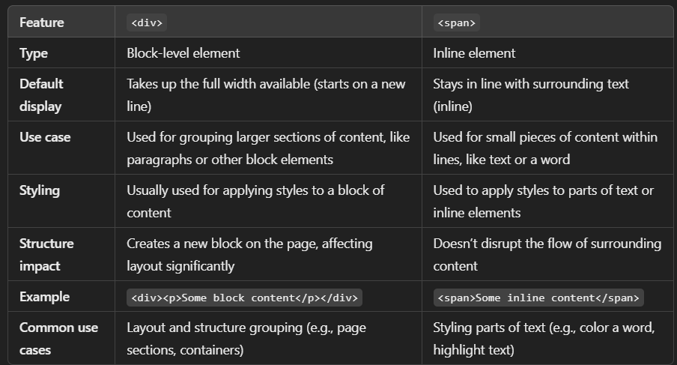

In summary:

* **<div>**: Used for layout and large content blocks.
* **<span>**: Used for inline text and smaller content within a line.

2) id vs class tags diffrence in html in tabular format.

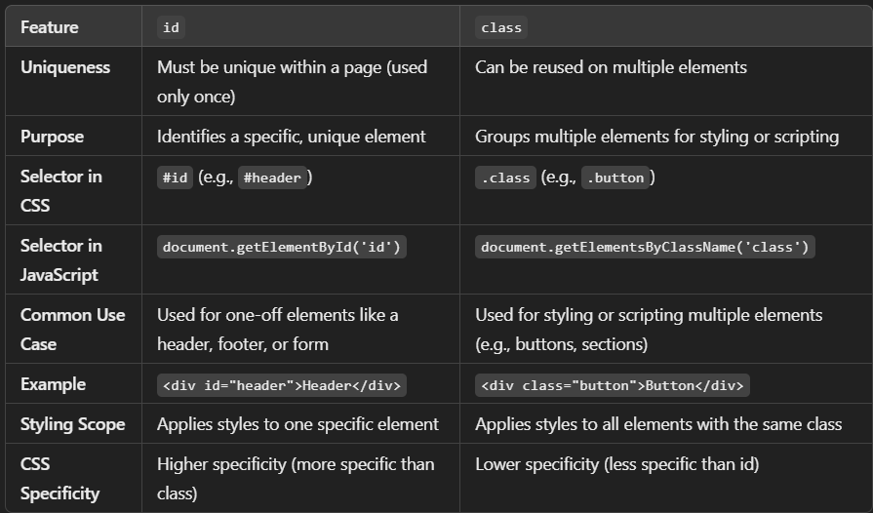

In summary:

* **id**: Used for uniquely identifying an element.
* **class**: Used for styling or targeting multiple elements.

3) can we use block elements in inline elements ?

No, technically, block-level elements **should not** be placed inside inline elements according to the HTML specification.

**Why?**

* **Block-level elements**: These elements (like <div>, <p>, <h1>) take up the full width and usually start on a new line.
* **Inline elements**: These elements (like <span>, <a>, <em>) stay within the flow of the surrounding content.

**What happens if you use block elements inside inline elements?**

* Browsers may automatically correct or "fix" the code by breaking the structure or moving the block elements out of the inline context, which can lead to unpredictable results.
* It's generally considered invalid and bad practice in HTML.

Example of invalid code:

<span><div>This is invalid HTML</div></span>

**Best practice:**

* Use **block elements** to wrap other block elements.
* Use **inline elements** for wrapping small pieces of text or inline content.